Coffee Cafe is a locally owned coffee bar in a Palmerston North neighbourhood. The purpose of this project is to design a website that promotes the cafe, presents important customer information clearly, and appeals to its target audience. To achieve this, the group identified the client’s expectations, analysed the target audience, reviewed competitor websites, and planned an appropriate sample page layout.
1. Three Client Expectations
1. The website should promote Coffee Cafe as an attractive and welcoming local coffee bar.
2. The website should clearly present key information such as the menu, location, opening hours, and contact details.
3. The website should appeal to local customers and encourage them to visit the cafe.
2. Target Audience
The target audience of the Coffee Cafe website includes local residents, students, and working adults in Palmerston North who are looking for a comfortable and welcoming place to enjoy coffee, meet friends, relax, or study.
Age: 16-40
Gender: All genders
Interests: coffee, cafe culture, relaxing, meeting friends, study, and casual socialising
Socio-economic criteria: local residents, students, and working adults looking for affordable to moderately priced drinks and snacks

This audience profile is important because it guides the layout, colour choices, and content tone of the website. Since the intended users are likely to prefer a friendly and easy-to-use website, the design aims to be visually warm, simple to navigate, and informative without feeling crowded.
- Competitor Websites
To develop an effective website for Coffee Cafe, the group reviewed several competitor or similar cafe websites in order to understand useful design features and common weaknesses.
1. Starbucks NZ
URL: https://www.starbucks.co.nz/
2. Columbus Coffee NZ
URL: https://www.columbuscoffee.co.nz/
3. Cafe Esplanade
URL: https://www.esplanadecafe.com/what-we-do
These websites were chosen because they represent different types of cafe branding and website design. Starbucks NZ represents a strong international coffee brand, Columbus Coffee NZ represents a well-developed cafe chain in New Zealand, and Cafe Esplanade represents a more local and community-oriented cafe website.
- Competitor Strengths and Weaknesses
Competitor 1: Starbucks NZ
Strength 1: The branding is strong, with a unified seasonal colour theme and professional magazine-style layouts.
Strength 2: Key actions such as Rewards, Careers, and Find a Store are easy to locate with clear buttons.
Weakness 1: Some buttons and the chat bubble overlap the text, which looks like a layout problem.
Weakness 2: Too many consecutive promotional banners make the homepage crowded and distract from basic information.
Competitor 2: Columbus Coffee NZ
Strength 1: The yellow-and-black colour scheme and diamond motif make the brand identity distinctive and consistent.
Strength 2: Each section has a clear call-to-action, from viewing menus to joining rewards or shopping online.
Weakness 1: The floating navigation bar overlaps the newsletter form when scrolling down.
Weakness 2: Some sections contain awkward empty space, and the signup form asks for too many fields.
Competitor 3: Cafe Esplanade
Strength 1: The local history story and real photos of the historic building make the website feel authentic and trustworthy.
Strength 2: The navigation is simple, with only four items, and the footer provides complete contact information.
Weakness 1: The page is text-heavy, with plain paragraphs and large empty gaps that make it look unfinished.
Weakness 2: There are no strong calls-to-action, such as a menu link, booking option, or online ordering feature.
Overall, the competitor analysis showed that a successful cafe website needs clear navigation, strong visual identity, concise content, and visible customer actions. It also showed that overly crowded pages or overly plain pages can both reduce user interest and usability.
- Sample Page Layout Plan
Based on the client expectations, target audience, and competitor analysis, the group developed a final sample homepage layout for Coffee Cafe. The layout is designed to present the cafe as a welcoming and attractive local coffee bar while also making important customer information easy to find.
The homepage uses a jello layout with a centred content area and a maximum width of 1100px. This creates a balanced and organised appearance while also leaving enough white space around the content. The use of white space helps the page feel less crowded and supports the calm and comfortable atmosphere that Coffee Cafe wants to communicate to its customers.

The homepage includes all key sections required for the website: a Header, Hero Section, Featured Menu, About Section, Visit Us Section, and Footer. The header contains the Coffee Cafe name and a simple navigation bar with the links Home, Menu, About, Visit Us, and Contact. This allows users to move through the page easily and find the information they need.
Target Audience Appeal
The page layout is designed to appeal to the target audience of local residents, students, and working adults. The warm colour palette, relaxed visual style, and simple structure make the page feel friendly and approachable. The homepage highlights practical information quickly, which is useful for busy users who may want to find the menu, location, or opening hours without spending too much time searching.
The Layout Design
The hero section is used as the main visual focus of the page. It includes a welcoming heading, a short introduction, and a clear call-to-action button, "Explore Our Menu". This helps attract attention early and encourages users to explore the website further. The homepage is arranged in a clear visual hierarchy so that the user can move naturally from the hero section to the menu, then to the about and visit information.
Navigation
Navigation is placed at the top of the page and uses clear labels that are familiar and easy to understand. The navigation links support best web design practice because they are simple, consistent, and directly related to the content of the website. This makes the layout easier to use for first-time visitors.
Color and Graphics
The page uses a coffee-inspired colour palette, including deep coffee brown, caramel, warm beige, creamy white, and taupe brown. These colours create a warm and inviting atmosphere and fit the identity of a local coffee cafe. The graphics and illustrations also support the theme of coffee, food, and comfort, making the homepage more visually appealing without making it too busy.
Text Content
The text content is short, clear, and relevant to the purpose of the site. Section headings are direct and easy to scan. The homepage avoids long blocks of text and instead uses short paragraphs, menu cards, and grouped information. This makes the content easier to read and more suitable for web users.
Accessibility
Accessibility is supported through strong colour contrast, clear section headings, readable text sizes, and simple navigation. Important actions, such as exploring the menu or finding contact information, are easy to locate. The content is divided into logical sections, which helps users scan the page more effectively.
Overall, the sample page layout is designed to be visually consistent, user-friendly, and clearly connected to the needs of the client and the target audience.
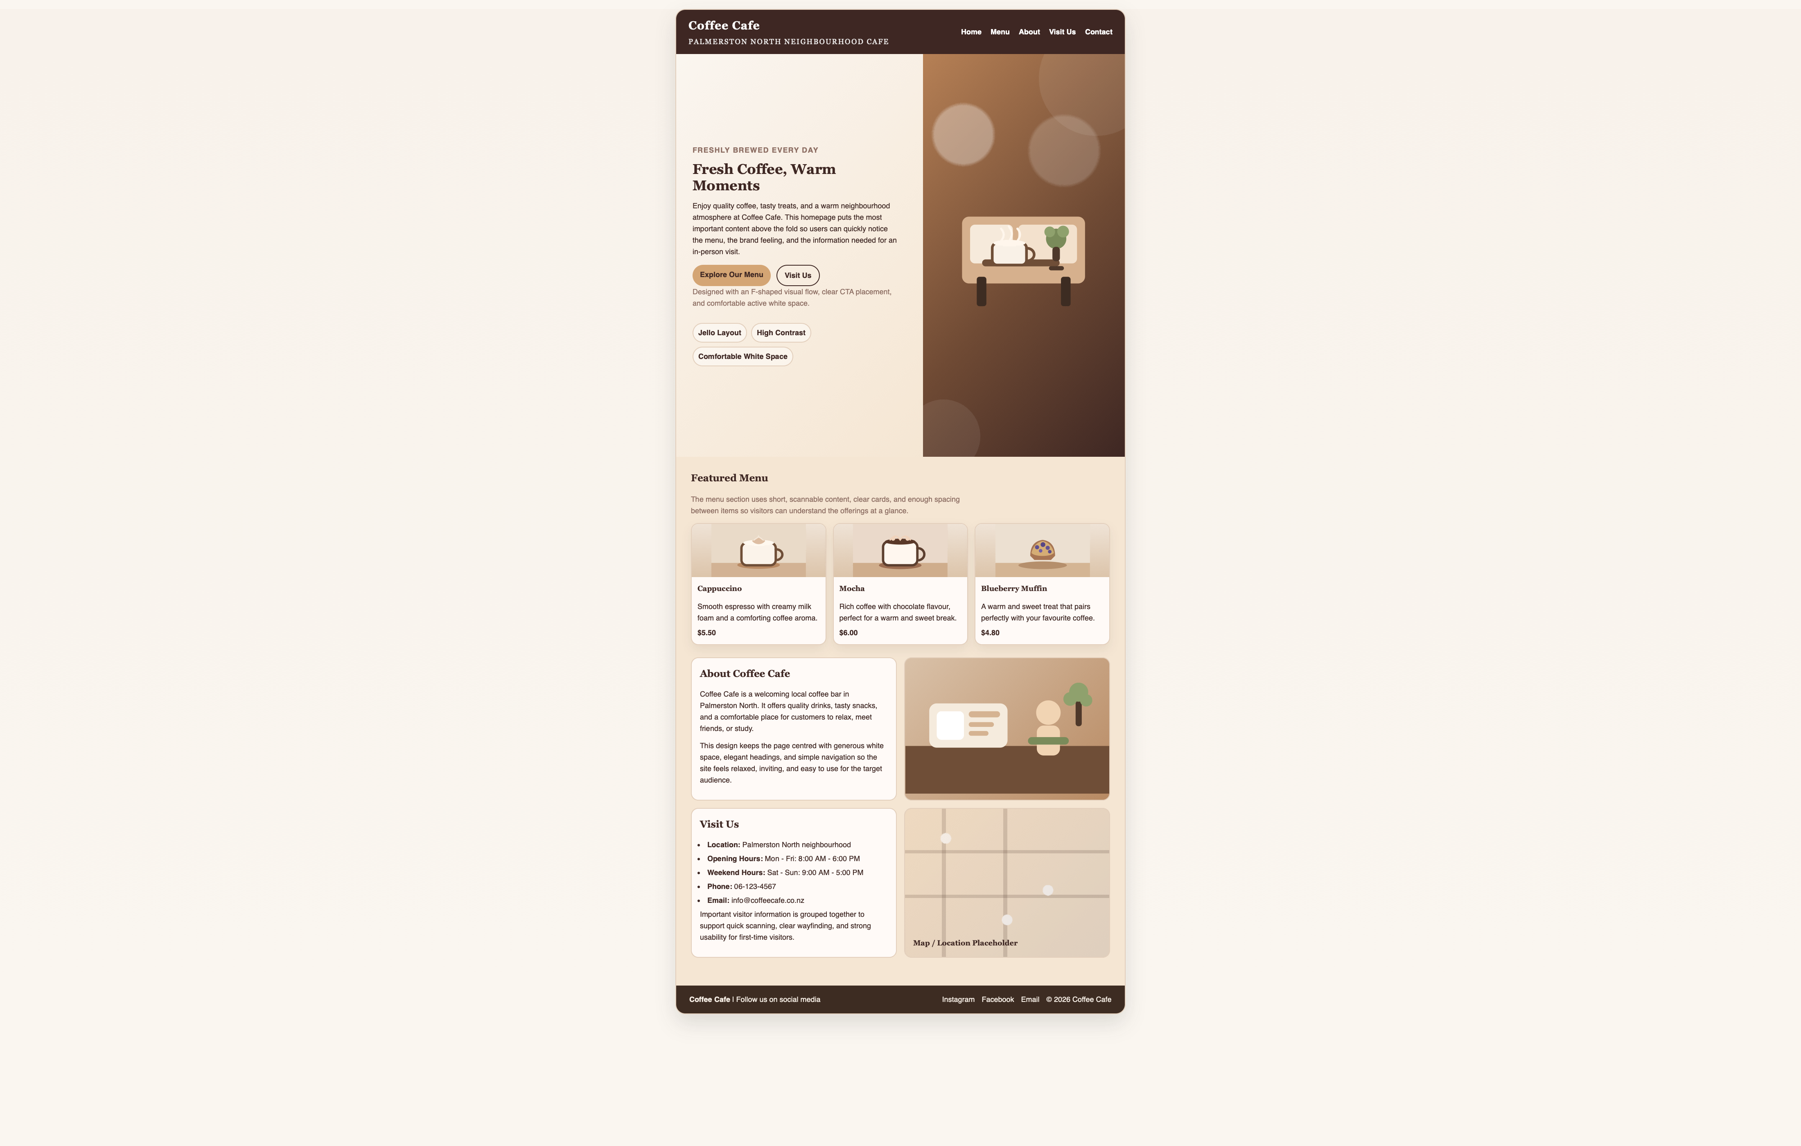
Figure 1. Final homepage sample page layout for the Coffee Cafe website
6. Design Notes
Navigation
The navigation is simple and consistent, using the labels Home, Menu, About, Visit Us, and Contact. These labels are easy to understand and match the main information that visitors are likely to look for on a cafe website. A clear top navigation bar improves usability and helps users move through the page without confusion.
Page Layout Type
The website uses a jello layout with a maximum width of 1100px. This layout keeps the content centred while still allowing it to adapt better to different screen sizes than a completely fixed layout. It also creates active white space on both sides of the page, which helps reduce visual clutter and supports the relaxed and comfortable feeling of the Coffee Cafe brand.
Color Scheme
The colour scheme uses deep coffee brown (#3E2723), caramel (#D4A574), warm beige (#F5E6D3), creamy white (#FAF6F0), and taupe brown (#8D6E63). These colours were selected because they reflect the visual identity of a coffee cafe and create a warm, inviting atmosphere. The contrast between dark text and light backgrounds also improves readability.
Fonts
The headings use a Playfair Display style because it gives the page a slightly elegant and cafe-appropriate appearance. The body text uses a Lato or Helvetica style because sans-serif fonts are clean, simple, and easy to read on screen. This combination helps balance visual style and readability.
Accessibility
Accessibility is supported through strong colour contrast, simple navigation, clear section headings, and readable text sizes. The page content is divided into clear sections so that users can scan the information more easily. Important actions, such as exploring the menu or finding contact information, are made visible and easy to locate.

7. Member Tasks
Chu Jintong: organised the working document, wrote the opening, the client expectations, and the target audience section, and coordinated the group's progress.
Fan Yize: responsible for competitor analysis and report writing support.
Han Linyuan: responsible for the sample page layout, colour scheme, visual presentation, and the first homepage draft and the url of the homepage is https://hhllyy00.github.io/coffee-cafe-layout/
Ji Yiran: responsible for page structure, layout decisions, and design notes.

